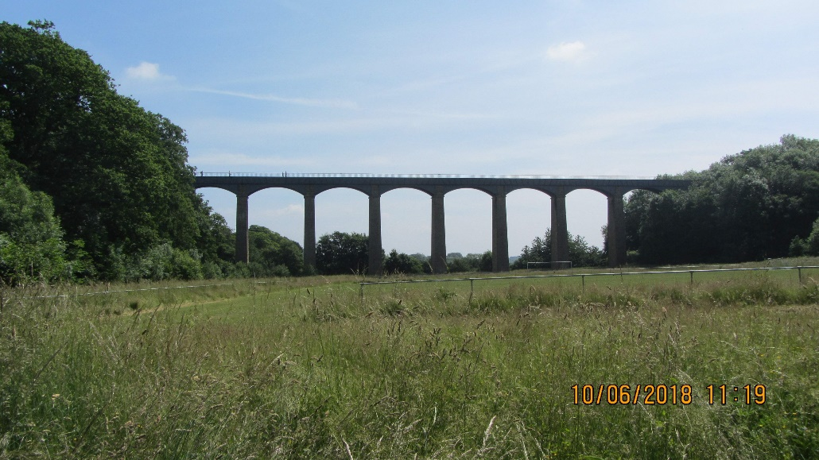

Early start, rolled up to Llangollen fitting in our first tea stop at Hereford.

Had a good view of the famous Pontcysyllte Aquaduct, then on to Horse Shoe Pass, stopping at the Ponderosa for lunch.

JUNE 10th 2018

**THE LONG WAY ROUND**

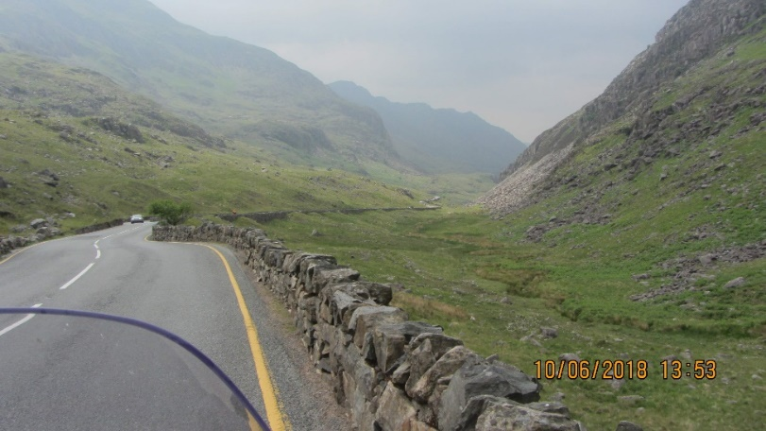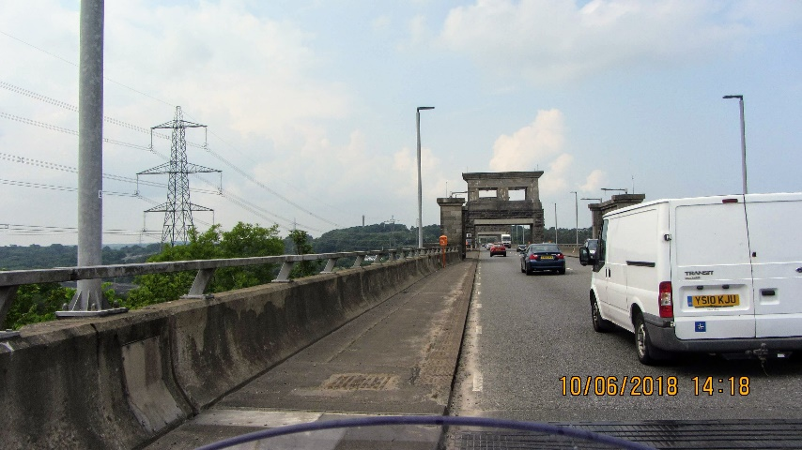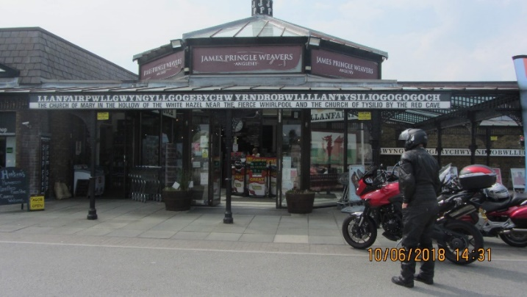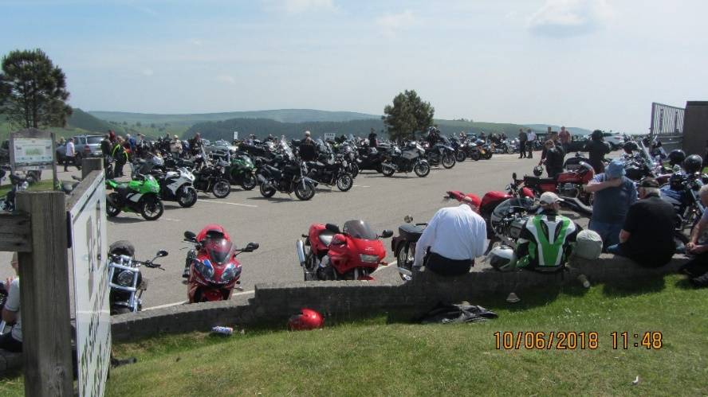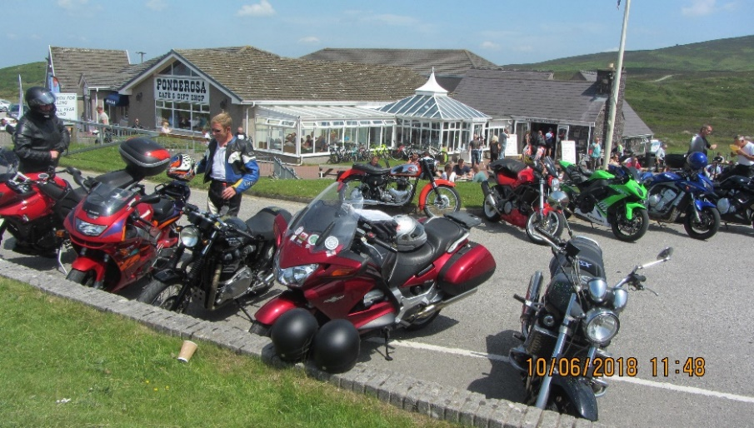

**LIANFAIR P.G. ANGLESEY**

Had another tea stop at Llanfair PG.

**PASS OF LAMBERIS**

**BRITTANIA BRIDGE**

**THE PONDEROSA**

Continued on to the Pass of Lamberis hopping over the Brittania Bridge to Anglesey.

**LLANFAIR PG.**

**THE PONDEROSA**

**THE PONDEROSA**

**PONTCYSYLLTE AQUADUCT**

**LAMBERIS PASS**

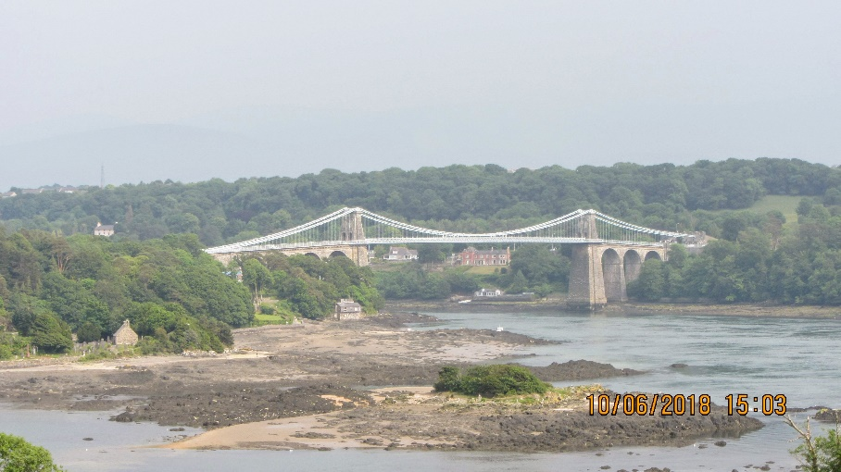

This was followed by a trip over the Menai Bridge, up over the Sychnant Pass, travelling down to Conwy Castle.

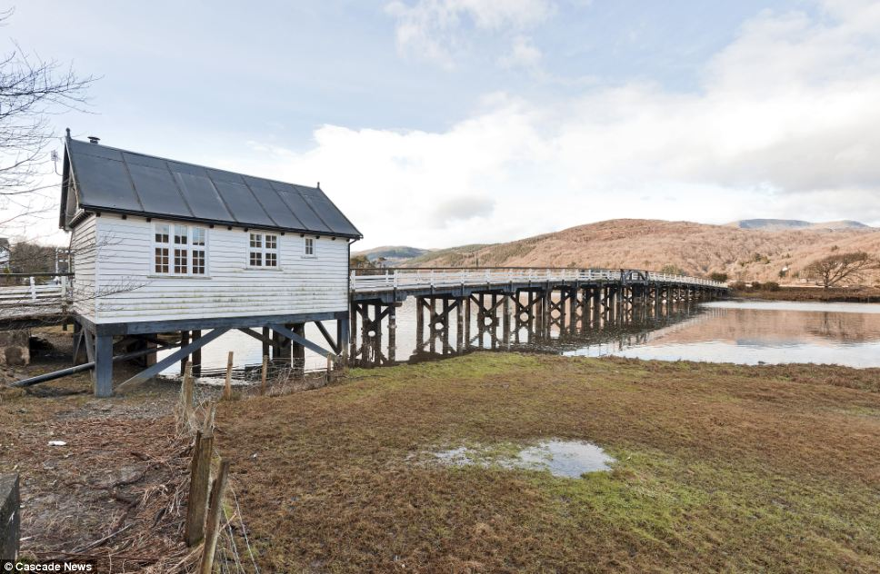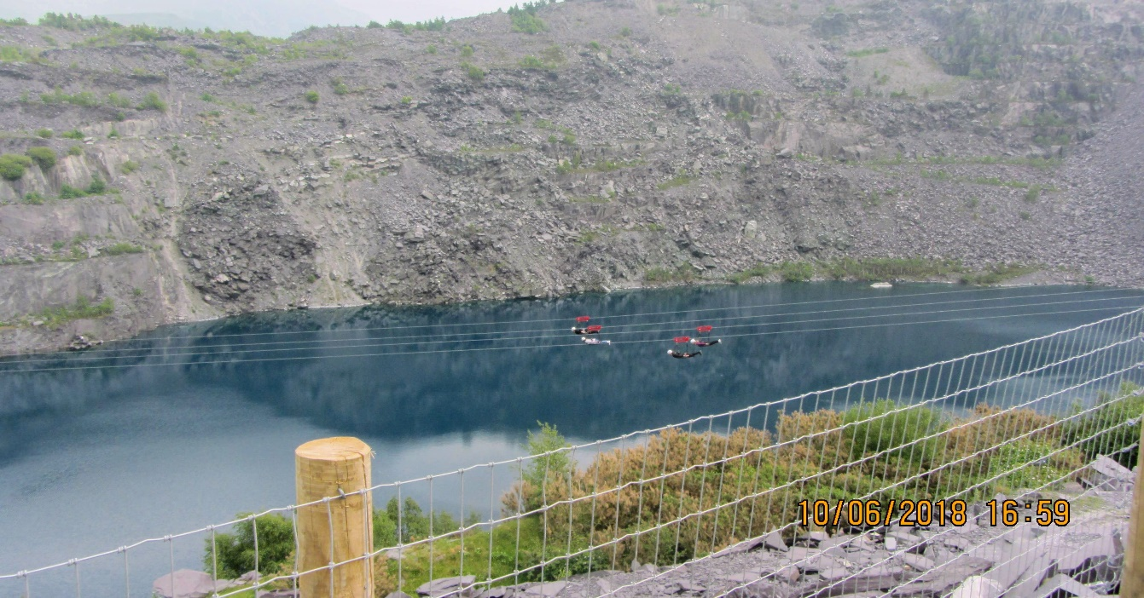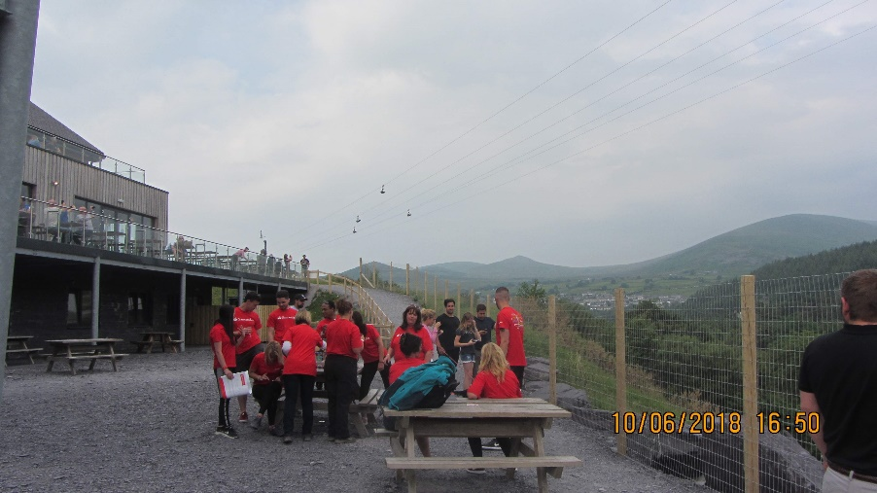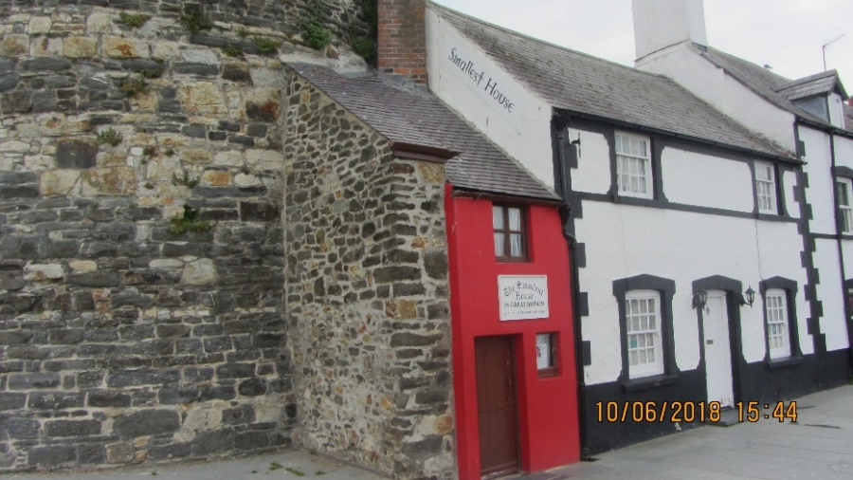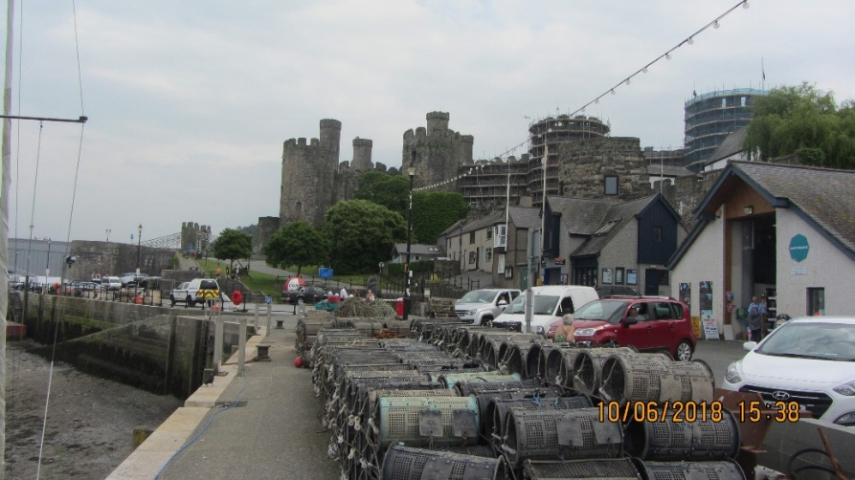

Stopped for our evening meal at Dinas Mawddwy.

Good weather all day, a great….. but very long day’s motorcycling!!!

Tony ( Pan Euro)

After watching people travelling at over a hundred miles an hour!! We made our way home calling in at Mawddach Estuary to see the notorious wooden toll bridge at Penmaenpool.

**CONWY CASTLE**

**WOODEN TOLL BRIDGE AT PENMAENPOOL**

**ZIP WORLD**

**ZIP WORLD**

**BRITAINS SMALLEST HOUSE CONWY**

Saw the Smallest House in Gt Britain then on to Bethesda which eventually led us to Zip World.

**MENAI BRIDGE**